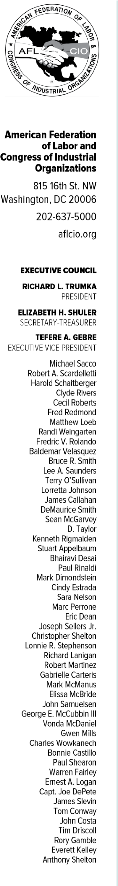


February 11, 2021

His Excellency Mostafa Madbouly
Prime Minister of the Arab Republic of Egypt

Email: Media.office8@op.gov.eg; Questions@cabinet.gov.eg;
Primemin@idsc.gov.eg

Dear Prime Minister Mostafa Madbouly:

On behalf of the over 12 million members of the AFL-CIO, I write to express our solidarity with the 7,200 workers of the Egyptian Iron and Steel Company, who have been engaged in a sit in for fifteen days to protest the decision to liquidate the company. The AFL-CIO is concerned that these workers are facing the loss of their jobs during a time where COVID-19 has already led to substantial increases in unemployment and poverty, not only in Egypt, but globally.

The AFL-CIO stands with the brave workers exercising their fundamental freedoms of association and assembly to defend their rights. We call on the management of the company to respect the right of these workers through their union select representatives of their choosing to negotiate these important decisions that affect their lives and livelihoods. Workers through their unions and
management find common ground to develop solutions that ensure the sustainability of companies which will benefit all parties and the economy overall. These workers have extensive experience through their employment and can offer suggestions for developing the company and implementing modifications to ensure the continuation of its operations. These ideas generated by workers should be discussed through dialogue with the General Assembly.

The Egyptian Iron and Steel Company has been an important national symbol of Egypt’s industry since its establishment in 1954 as the first integrated steel production complex in the entire Arab world. As such, the decision to liquidate it is a decision that will affect the country at large and is strongly opposed by citizens. Therefore, the protesting workers are not only demanding their rights, but are protesting on behalf of Egypt’s working class.

Letter to His Excellency Mostafa Madbouly
February 11, 2021
Page two

The AFL-CIO calls on the General Assembly to immediately cancel the decision to liquidate the company and agree to dialogue with the chosen representatives of the workers to find an agreeable resolution that balances the economic concerns and the interests of the workers.

Sincerely,

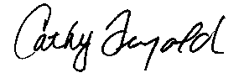
Catherine Feingold
International Director

CF/jp
OPEIU#2

